DATE : July 6, 2018
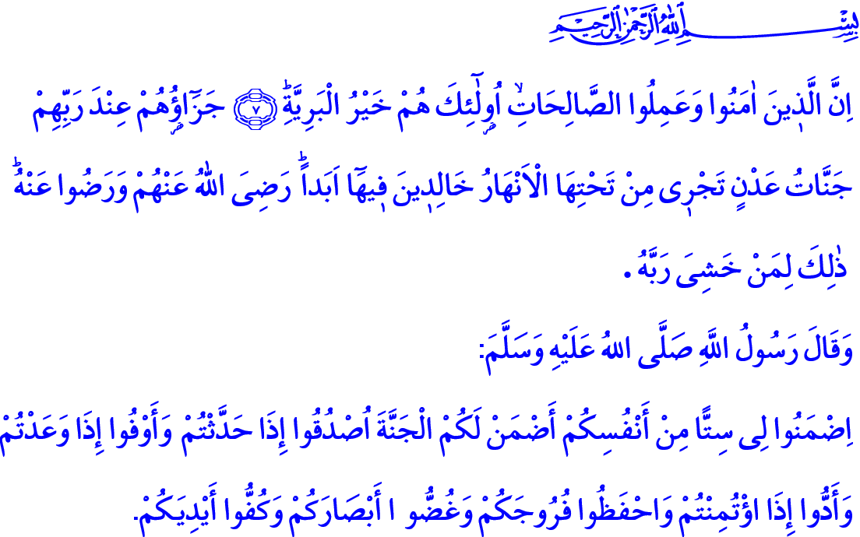
GOOD DEEDS THAT LEAD TO ALLAH’S COUNTENANCE
Honorable Believers!
One day, during a conversation with his companions, the Messenger of Allah (s.a.w) asked, “Who amongst you is fasting today?”. Abu Bakr replied, “I am.”. Then, Our Prophet asked these questions, “Who amongst you joined a brother’s funeral today? Who amongst you served food to the needy? Who amongst you has visited the sick today?”
Abu Bakr al-Siddiq (r.a.) replied all these questions affirmatively by saying, “I did.” Thereupon, Our Prophet gave us the following good news in the presence of his companions, “Anyone in whom (these good deeds) are combined will certainly enter paradise.”
Estimable Muslims!
The reason for our creation is, first of all, to be cognizant of the Lord Almighty properly, to be bond with Him at the heart, and to observe what He commands and forbids. The purpose of our being is to establish faith, good deeds, goodness and good morality in life, which can be achieved by faithfully complying with the Qur’an and the Sunnah. Because the Qur’an and the Sunnah are the most sound, the most reliable and the most essential guides in our journey of life. At the end of this journey, there is the Paradise, as a grace and reward from our Lord, for the servants of Allah who attain His countenance.
Dear Brothers and Sisters!
The first step in the path of truth that will take us to the Paradise is faith. Those who have faith in the existence and oneness of Allah will reach the Paradise. Those who abide by the tenets of faith at the heart will gain eternal blessings. Our duty is to remain loyal to our faith till the last breath, to keep our promise of servitude to our Lord, and to reflect our faith in our words and behaviors, and keep it alive with our deeds. Hence, our Almighty Lord enjoins in the Holy Qur’an, “Indeed, they who have believed and done righteous deeds - those are the best of creatures. Their reward with Allah will be gardens of perpetual residence beneath which rivers flow, wherein they will abide forever, Allah being pleased with them and they with Him. That is for whoever has feared his Lord.”
Brothers and Sisters!
The second step on the way to the Paradise is good deeds. There is no limit to the good deeds, i.e. the good and beautiful manners and true and meaningful moves, which we hope will lead us to attain Our Lord’s countenance. Each benevolent word uttered with the awareness of servitude, each beautiful action worthy of being a human being, or each good intention that aims to attain Allah’s content are good deeds as long as the countenance of Allah is not given up for other aims or expectations.
Dear Brothers and Sisters!
Every act of worship is a good deed. However, our worship, which will take us to the Paradise, are the ones which also help us attain beautiful traits. Our prayer (salah) should protect us from sinning and evil deeds. Our fasting (sawm) should protect our tongue from bad words, and our hands, our minds and hearts from evils. Our pilgrimage (hajj) should strengthen our submission and our awareness of the Ummah. Our Zakat, our charities and sacrifices should remind us of the fact that we should not be captivated by worldly possessions.
Honorable Believers!
The most effective way that makes faith perfect and takes a believer to the Paradise is good morality. Believers show affection and compassion to their parents, spouse, children, neighbors and relatives, and every living thing. They do not hurt anybody with their actions or words. They inspire trust in their surroundings. They are as true as commanded by our Lord and never deviate. They do not lie even when they know they will be hurt. They keep their promises. They do not waste their lives with unnecessary and meaningless things. Those destined to the Paradise observe only Allah’s countenance in every moment of their lives on every matter.
Brothers and Sisters!
At this time of Jumu’ah, let us question ourselves while supplicating for salvation and becoming of those deserving the Paradise. Let us ask ourselves these questions: For what are we spending our lives, entrusted to us by our Lord? Will this path we follow take us to the Paradise? Or will it deviate us from the path to the Paradise? Are we building a bridge with our living that will take us to the Paradise? Or are we building walls between us and the Paradise? Do our words and behaviors have sincerity? Or are we just wasting our deeds with hypocrisy and vanity?
Dear Believers!
I would like to conclude this khutbah with this hadith of our Beloved Prophet, “If you warrant me on these six things, and I will warrant you on the Paradise; Say the truth when you speak. Keep your word when you promise. Respect it when you are entrusted with something. Protect your chastity and dignity. Protect your eyes from haram. Do not extend your hand to evil things.”

Muslim, Fadhail al-Sahaba (Merits of the Companions), 12.
Bayyinah, 98/7-8.
Ibn Hanbal, V, 323. General Directorate of Religious Services

