Date: 04.12.2020
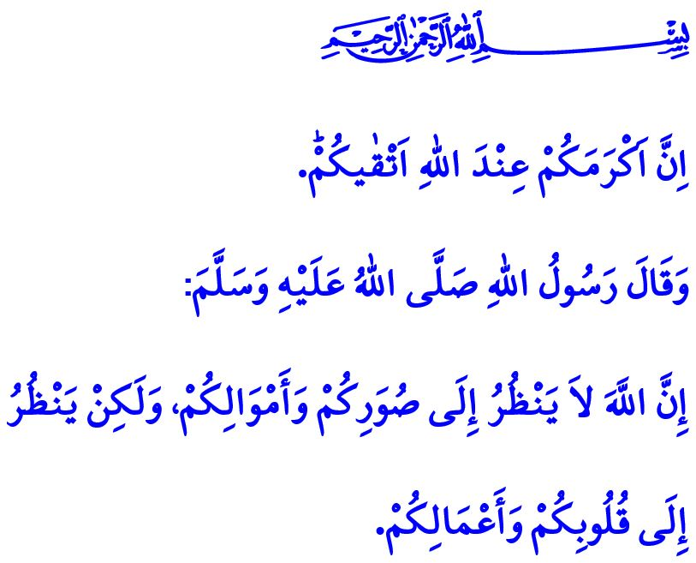
BEING A PERSON WITH DISABILITIES:
A TRIAL THAT LEADS TO HEAVEN
Honorable Muslims!
The Almighty Allah (swt) states in the verse I have recited as follows: “Indeed, the most noble of you in the sight of Allah is the most righteous of you.”
In the hadith I have read, Prophet Muhammad (saw) says: “Allah does not look at your outward appearance and your wealth but He (swt) looks only at your hearts and your deeds.”
Dear Believers!
What makes the human notable in the sight of our Lord Almighty is not fame, might, beauty, health, or wealth. Humans as the most honorable of all creation are already valuable before Allah and the way to increase this value is possible only through faith, worship, good deeds and good morals. Therefore, health conditions and disabilities, present at birth or developed later, are a reality of life and cannot be referred to as an imperfection of people. Quite the opposite, they are means of trial and tribulation that lead to heaven in the end with patience, perseverance and endeavor.
Dear Believers!
It is a commandment of Allah (swt) and a sunnah of our Prophet (saw) to protect our health and seek treatment when needed. The pandemic facing us today reminds us one more time of this responsibility. Each and every one of us is responsible for observing the measures and protecting ourselves and our nation from the pandemic. But if we contact the disease decreed by Allah despite all our efforts, then we need to get treatment, remain spiritually firm and be patient.
Dear Brothers and Sisters!
Like all blessings in our possession, all hardships on our way are means for us to earn Allah’s (swt) appreciation. Let us not forget that every person’s responsibility is only to the extent he or she is able. It is a duty upon all of us to support our ill brothers/sisters and their families and have them feel, through our prayers and aids, that they are not alone and helpless. In the same way, it is a duty upon all of us to instill hope in our brothers/sisters with disabilities through the love we nurture in our hearts, and facilitate their lives. Regardless of the nature of their problems, it is a source of honor, peace and merit for us to be an eye for those who are not able to see, a tongue for those who are not able to speak, an ear for those who are not able to hear, a pair of feet for those who are not able to walk, and a pair of hands for those who are not able to take hold.

Hujurat, 49/13.
Muslim, Birr, 34. General Directorate of Religious Services

