Date: 11.06.2021
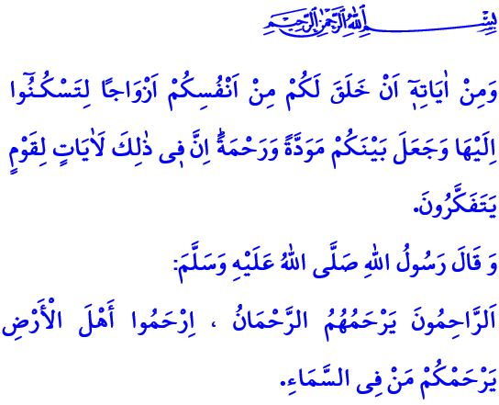
COMPASSION AND PEACE IN FAMILY
Honorable Muslims!
In the verse I have recited, our Lord Almighty (swt) states as follows, “And of His signs is that He created for you from yourselves mates that you may find tranquility in them; and He placed between you affection and mercy. Indeed in that are signs for a people who give thought.”
In the hadith I have read, the Messenger of Mercy (saw) states as follows, “The Compassionate One (Al-Rahman) has mercy on those who are merciful. If you show mercy to those who are on the earth, He Who is in the heaven will show mercy to you.”
Dear Believers!
Allah the Almighty (swt) has not left humankind, the most valuable of all creation, alone on earth, and blessed them with having a family. Family is a blessing that provides one’s soul with peace, tranquility, and health. It is an institution that is guarded by our Lord Almighty’s (swt) grace, and beautified by love, affection, and compassion. It is a warm home where the woman is entrusted to the man, and the man is entrusted to the woman, and, in short, all family members are entrusted to each other. Family is the core and essence of the society. It is for this reason that starting a family also means building a society.
Dear Believers!
Being and maintaining a family is as important as starting one. Being a family means meeting in the same world of feelings and thoughts. It means sharing a life in line with the pleasure of Allah (swt). It means living as conscious not only of being together in this world but also in the Hereafter.
Being a family means embracing tightly all the values that keep a family standing. Compassion comes on top of the values that keep a family standing. Compassion, which is the manifestation of our Lord’s (swt) name al-Rahman, means loving the created for the sake of the Creator. Compassion means not hurting anybody and not getting hurt by anybody. It means sharing, forgiving, and tolerating. It means being a tender-hearted person and speaking in the language of love.
Dear Believers!
Today, our need to train our hearts and consciences with compassion is even greater. Today, we need more than ever to take heed of the Prophet Muhammad’s (saw) following advice: “The best of you is he who is best to his family, and I am the best among you to my family.”
Then, let us make every effort to embellish with peace our homes, which we start in line with the commandment of Allah (swt) and the sunnah of the Prophet Muhammad (saw), to be a family, and to remain a family. Let us ensure that the language of heart, kindness, and justice prevail our home that is leavened with love. Let us enable every member of our family, particularly our children and elderly, to drink heartily from the spring of compassion. Let us work to ensure that our homes bear the marks of the happy family of the Messenger of Allah (saw), who is our guide to compassion. Let us together rebuild the civilization of compassion that starts from the family and spreads to the society.

Rum, 30/21.
Abu Dawud, Adab, 58.
Tirmidhi, Manaqib, 63. General Directorate of Religious Services

