Date: 21.07.2023
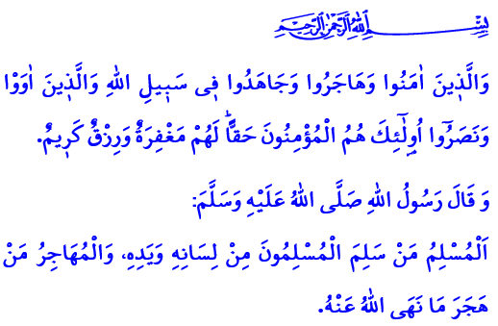
HIJRAH: A BLESSED JOURNEY IN PURSUIT OF IDEALS
Honorable Muslims!
In the verse I have recited, our Almighty Lord (swt) states, "Those who believed, migrated, and struggled in the cause of Allah, and those who gave them shelter and help, they are the true believers. They will have forgiveness and an honourable provision."
In the hadith I have read, our Prophet (saw) says, "A Muslim is the one from whose tongue and hands the Muslims are safe. A Muhajir (emigrant) is the one who refrains from what Allah has forbidden."
Dear Believers!
Thanks to the grace and favor of Allah the Almighty (swt), we reached the 1445th Hijri year last Wednesday. Endless thanks and praise be to our Lord (swt) for blessing us with another Hijri year. May the Hijri New Year be auspicious and blessed.
The first year of the Hijri calendar was 622, when our Prophet (saw) and his companions migrated from Mecca to Madinah. In that year, Muslims, led by the Messenger of Allah (saw), migrated to Madinah to practice Islam more comfortably after the days of suffering in Mecca. During his caliphate, Umar declared the year of this incident to be the beginning of the Hijri calendar.
Dear Muslims!
Hijrah is one of the most important turning points in human history. Hijrah is not just a migration. Hijrah is also not traveling from one place to another to gain some temporary benefit. Hijrah is definitely not fleeing from somewhere out of fear of life and property. Quite the contrary, hijrah is a blessed journey that is embarked upon for the sake of Allah's pleasure, leaving aside all worldly expectations and aspirations. Hijrah is a blessed journey to lead a life of ideals. Hijrah is the abandonment of everything that draws one away from the purpose of creation.Hijrah is a committed turn from evil to good, from oppression and injustice to justice and truth. Hijrah is turning away from all kinds of carnal desires and wishes that divert one from worshipping Allah (swt). Hijrah means abstaining from haram and sins. Hijrah is to seek refuge in the boundless mercy of our Lord (swt) through repentance and prayer.
Dear Believers!
The purpose of the hijrah is to make an effort to raise responsible, self-aware, and beneficial individuals. Hijrah means striving to build a society that lives in an environment of virtue, peace, security, and tranquility. The purpose of hijrah is to strive to bring values of love, compassion, and solidarity to all of humanity.
How fortunate are those who have understood the true purpose of hijrah. Blessed are those who are honest and truthful in what they say and what they do. Blessed are those who are true servants of Allah (swt). Blessed are those who allow their lives to be governed by the truths of Islam.
Dear Muslims!
There is an important point I would like to point out to you. Lately, we have been hearing a lot of news about forest fires and wildfires. These fires burn our lungs. A lot of living beings are disappearing along with the forests. Let us not set campfires in the forest, even for picnics. Let us not leave litter that causes fires in the forests. Let us be on the lookout for people with evil intentions who threaten our forests. Let us pay attention to the warnings of the authorities about fires and disasters. Let us make it easier for them to work. Let us grow new forests to replace our destroyed ones, following the order of the Messenger of Allah (saw), "If the Final Hour comes while you have a shoot of a plant in your hands and it is possible to plant it before the Hour comes, you should plant it." Let us not forget that our forests and the nature are entrusted to us. It is the common duty of all of us to protect what is entrusted to us. May our Lord Almighty (swt) protect our country and nation from all kinds of disasters and calamities.

Anfal, 8/74.
Bukhari, Iman, 4.
Ibn Hanbal, III, 184. General Directorate of Religious Services

