Date: 22.10.2021
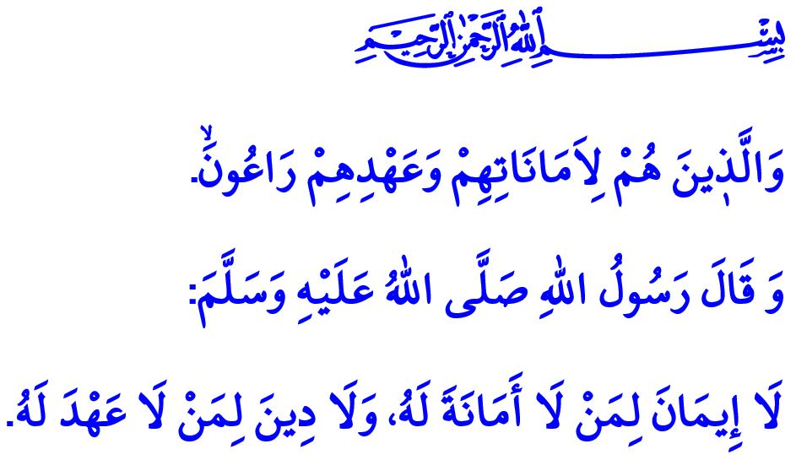
HIS (SAW) LEGACY FOR US: HIS UNIQUE LOYALTY
Honorable Muslims!
We’ve left another night of Mawlid al-Nabi behind us. We continue to observe this week, in which Mawlid al-Nabi falls, with the theme “Our Prophet and the Society of Loyalty” this year. In this Friday’s khutbah, let us remember instances of loyalty from the life of our beloved Prophet (saw), who was sent as mercy to the worlds.
Dear Believers!
First and foremost, he (saw) was devoted to his Lord (swt). In this regard, he (saw) never failed to observe his servitude and devotion, allegiance and submission to the Almighty Allah (swt). One day, our mother ‘Aisha (ra) saw our Prophet’s (saw) swollen feet because of performing prayers at nights and asked, “O Messenger of Allah, why are you doing this when your past and future sins are forgiven?” Then, our Prophet (saw) said, “O ‘Aisha! Should I not be a thankful servant of Allah?”
Dear Muslims!
The Messenger of Allah (saw) was loyal to people. He (saw) was so loyal that he spent his whole life to help people achieve happiness in this world and in the Afterlife. In this regard, our Lord (saw) addresses His Beloved (saw) as follows, “Perhaps, [O Muhammad], you would kill yourself with grief that they will not be believers.”
Dear Believers!
Our Prophet (saw) was loyal to his family. He demonstrated his loyalty to his loving wife, who remained by his side through his most difficult moments, by having his tent set up near our mother Khadijah’s (ra) grave on the day Mecca was to be conquered; and to his daughter Fatimah (ra) by joyfully rising up to greet her anytime she came near him.
The Prophet of Mercy (saw) also placed a high value on loyalty to parents. One day after a young person said to him, “I have come to you, o Messenger of Allah, by leaving my parents weeping”, our Prophet (saw) said, “Go back to them, and make them smile as you made them weep.”
Dear Muslims!
Our beloved Prophet (saw) would follow through on his pledges and definitely keep his promises. In one hadith, he would tell the importance of loyalty as follows, “He who breaches one’s trust will never have his faith reach perfection. He who does not honor his word can never be pious in a perfect sense.”
The Crown Jewel of this world and the Afterlife (saw) was also loyal to the environment.He (saw) demonstrated his loyalty to the nature by saying “If the Final Hour comes while you have a shoot of a plant in your hands, you should definitely plant it.”; to animals by saying “Fear Allah regarding these animals that are unable to speak.”; and to water by commanding not to waste water even when performing wudu in a river.
Dear Believers!
Being loyal stems from faith and is a distinguishing feature of Muslims. Then, today, what falls upon us is to be loyal, just like our beloved Prophet (saw), whose ummah we are honored to be a part of. It is incumbent upon us to live by the verse “And they (believers) who are to their trusts and their promises attentive.” Let us not forget that being loyal to our Lord (swt), people, family, environment, and pledges would help us achieve the pleasure of Allah the Almighty (swt) and would be conducive for us to attain happiness in this world and in the Afterlife.

Muslim, Sifat al-Munafiqin, 81.
Shu’ara, 26/3.
Abu Dawud, Jihad, 31.
Ibn Hanbal, III, 134.
Ibn Hanbal, III, 184.
Abu Dawud, Jihad, 44.
Ibn Majah, Taharah, 48.
Mu’minun, 23/8. General Directorate of Religious Services

