Date: 05.03.2021
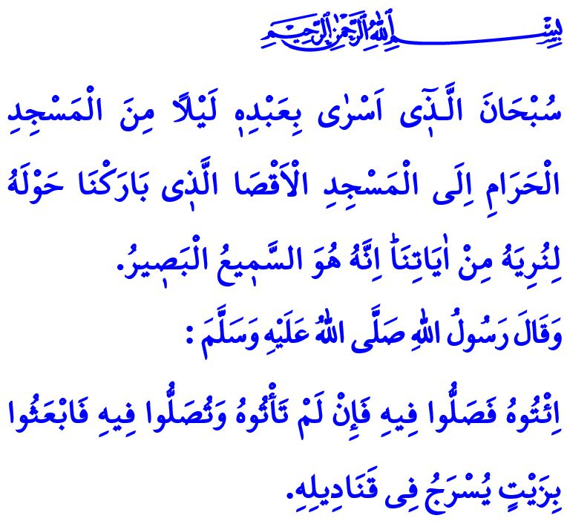
ISRA AND MI’RAJ
Honorable Muslims!
We are in the Three Holy Months, the season of grace and mercy, blessing and benefaction. Inshaallah, we will welcome and enjoy the Lailat al-Mi‘raj on the night that turns Wednesday to Thursday. May the Almighty Allah (swt) bestow health, peace and well-being upon our great nation, the ummah of the Prophet Muhammad (saw), and all humanity for the sake of this night. I wish you all a blessed Lailat al-Mi‘raj.
Dear Believers!
Our Lord Almighty (swt) states in the first verse of Surah al-Isra as follows, “Exalted is He who took His Servant [i.e., Prophet Muḥammad] by night from al-Masjid al-Haram to al-Masjid al-Aqsa, whose surroundings We have blessed, to show him of Our signs. Indeed, He is the Hearing, the Seeing.”
Isra, after which this surah is named, means the Prophet Muhammad’s (saw) journey from the Masjid al-Haram in Makkah to the Masjid al-Aqsa in al-Quds. On the other hand, Mi‘raj means his (saw) ascension to heavens where he witnessed Allah’s (swt) might and greatness, and was bestowed the grace, mercy and glad tidings of Allah (swt).
Dear Muslims!
The first stop in the Mi‘raj is al-Masjid al-Aqsa. About this blessed temple, the Prophet Muhammad (saw) says as follows, “Go and establish prayer at the Masjid al-Aqsa. If you cannot go and establish prayer there, then send some oil to be used in the lamps.”
This hadith teaches us that it is a duty upon all Muslims to exert efforts to instill in hearts the love for the Masjid al-Aqsa and to uphold and render prosperous, our time-honored values both materially and spiritually.
The sacred land al-Quds, where the Masjid al-Aqsa is located, is an Islamic land. It is the Dar al-Salam, namely the land of peace and prosperity. Throughout the history, al-Quds has been the symbol of freedom, justice and peaceful coexistence under Muslim rule.
Dear Believers!
As I conclude this Friday’s khutbah, I would like to share some of the advices our Lord (swt) has set out in the Surah al-Isra: Worship none but Allah. Be good to your parents; and should they attain old age, do not repel them, do not even say to them “fie”, but address them in terms of honor. Give the relative his right, and also the poor and the traveler. Do not be stingy and do not spend wastefully. Do not approach unlawful sexual intercourse. Do not kill the soul which Allah has forbidden, except by right, and do not pursue blood feud. Do not approach the property of an orphan. Fulfill every commitment. Give full measure when you measure, and weigh with an even balance. Do not pursue that of which you have no knowledge. Do not walk upon the earth exultantly.
Happy are those who heed our Almighty Lord’s (swt) message of guidance! Happy are those who are meticulous in their servitude to Allah (swt) and uphold the glad tidings and entrustments of the mi‘raj!

Isra, 17/1
Abu Dawud, Salat, 14. General Directorate of Religious Services

