Date: 29.01.2021
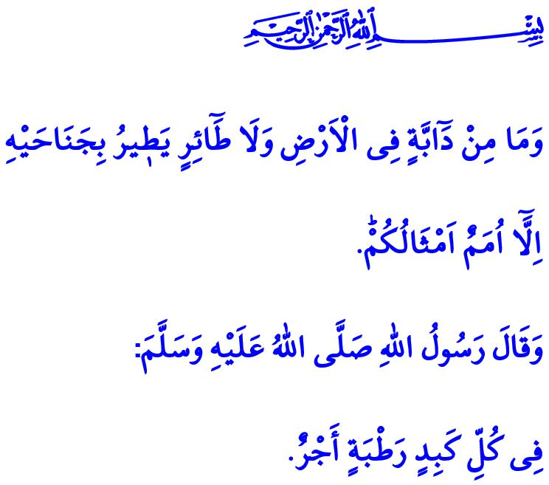
MERCY FOR ANIMALS:
A RELIGIOUS AND HUMAN RESPONSIBILITY
Honorable Muslims!
One day, the Prophet Muhammad talked about a man who filled his shoe with water from a well and offered it to a thirsty dog, and thus earned the appreciation of Allah and his sins were forgiven. When the Companions asked, “O Messenger of Allah! Shall we be also rewarded for showing kindness to the animals?”, the Prophet Muhammad said, “There is a reward for helping any living creature.”
Another day, the Prophet Muhammad (saw) talked about how a woman who got angry at a cat, kept it locked, and caused it to die from hunger earned the wrath of Allah (swt). He (saw) told that the merciless woman who took away the cat’s right to life was met with the punishment of Allah (swt). This is because there is also a sin and divine punishment for evil done to any living creature.

Dear Believers!
Just like every other creature in the universe, animals also serve as evidence of the existence and might of the Almighty Allah (swt). From the tiniest of them to the largest, every animal is valuable as a work of Allah and is entrusted to humans by Him (swt). We humans are liable to treat animals conscientiously, mercifully, and compassionately.
Islam forbids every kind of act that means oppression and torture to animals and that forces them into being treated in nonconformity with their reason of creation. The Prophet Muhammad (saw) warns us as follows, “There is no person who kills a small bird or anything larger for no just reason, but Allah, the Mighty and Sublime, will ask him about it.”
Dear Muslims!
It is stated in the Holy Qur’an as follows, “And there is no creature on [or within] the earth or bird that flies with its wings except [that they are] communities like you.” Indeed, animals, too, just like us humans, are the residents of the earth. Let us not forget that they, too, have the fundamental rights to life, protection from harm, and shelter. Let us look at the world of existence through the perspective of love, compassion and reflection. Let us not hurt any living creature. Let us be more careful and sensitive about animals particularly in winter conditions. Let us seek to earn the appreciation of our Lord (swt) by fulfilling our religious, conscientious and human responsibility.

Bukhari, Musaqat, 9.
Bukhari, Bad’ al-Khalq, 16.
Nasa’i, Sayd, 34.
An’am, 6/38. General Directorate of Religious Services

