Date: 01.01.2021
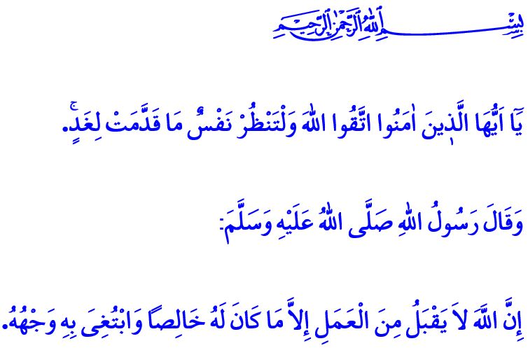
REFLECTING ON THE PAST, RENDERING THE FUTURE PROSPEROUS
Honorable Muslims!
Each passing year we move closer towards the Judgment Day before our Lord (swt), with each day tearing another leaf off our life calendar. As our life capital diminishes over time, the book of our deeds we will read in awe and have the reward or punishment for it in return in the Hereafter gets thicker.
Dear Believers!
Let us review the years we have left behind. Let us call our nafs to account and reckon with our own self. Let us turn from wrongs and sins and repent for them. Let us recall our responsibilities towards Allah, our own self, our family, and all that is created. In this regard, the Almighty Allah (swt) warns us as follows in the Holy Qur’an, “O you who have believed, fear Allah. And let every soul look to what it has put forth for tomorrow...”
Dear Muslims!
Let us plan our days to come in line with earning the appreciation of our Lord (swt). Let us not waste our life in the Hereafter while we pursue worldly whims and desires. Let us not forget that every decision we make, every word we utter and every action we take are seen and heard by and known to Allah the Almighty (swt), and that we will give an account of all these to Him (swt).
Dear Believers!
The Prophet Muhammad (saw) says, “Allah does not accept any deed except that which is purely for Him and for His sake.”
Then, let us turn to Allah in earnest. Let us show the resolve to lead a life in which our book of deeds will be filled with worship and benevolence. Let us keep our hope, faith, effort, trust in and support for each other alive at all times in these difficult days we are being tested by the pademic disease.

Hashr, 59/18.
Nasa’i, Jihad, 24. General Directorate of Religious Services

