Date: 24.01.2025
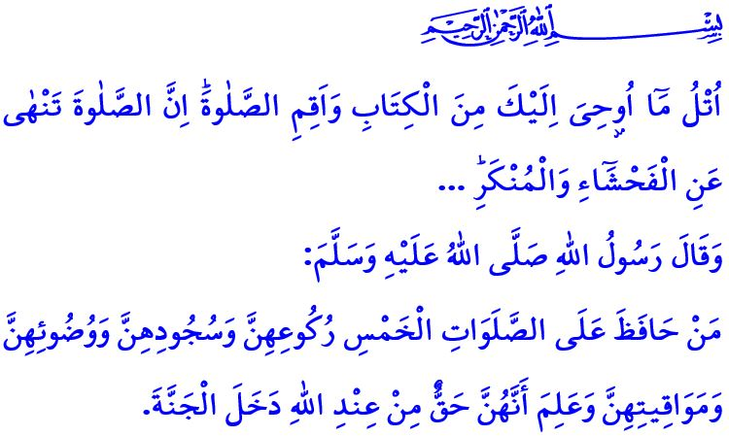SALAH: THE GIFT FROM THE MI‘RAJ AND THE PILLAR OF THE RELIGION
Dear Muslims!
Next Sunday evening marks the 27th night of Rajab. For centuries, we have commemorated the Isra and Mi‘raj of our Prophet (saw) on this night, rejoicing in the glad tidings our Almighty Lord bestows upon His servants. In this Friday’s khutbah, let us once again reflect on the significance of salah, a miraculous gift from the Mi‘raj that brings meaning to our lives and peace to our hearts.
Dear Believers!
Salah is one of the five pillars of Islam. It is a unique act of worship that begins with the Takbir and ends with the Salam, during which our minds, hearts, tongues, and, in short, our entire being turn towards our Lord. It is our duty of servitude that removes all differences, equalizes believers like the teeth of a comb in the sight of Allah, and unites them shoulder to shoulder.
Dear Muslims!
The five daily prayers should not be rushed, delayed, squeezed into a busy schedule, hastily completed, or left until the last moment. For salah is inseparable from being a Muslim. Muslims perform salah, and salah makes people truly human. The most valuable moments in a person’s life are those spent performing salah. A life lived without salah is a life wasted. Therefore, unless Muslims have a valid religious excuse, they cannot neglect their salah, thinking they can perform them later. It is the Muslims’ duty to organize their affairs in accordance with the salah times. In fact, our Prophet (saw) emphasizes the importance of this matter by saying, اَلصَّلاَةُ عِمَادُ الدّ۪ينِ “Salah is the pillar of religion.”
Dear Believers!
In the verse I have recited at the beginning of the khutbah, our Lord Almighty states, “Recite what has been revealed to you of the Book and establish prayer. Indeed, ˹genuine˺ prayer should deter ˹one˺ from indecency and wickedness...” Indeed, the purpose of our life is servitude, and the goal of our servitude is to be a good Muslim. For this reason, our prayers should serve to prevent us from engaging in what is haram. They should guard our tongues from lying, our hearts from hatred, and our hands from evil. They should purify us from all sin. If we are praying yet have become slaves to evil, we should reassess our hearts, our earnings, and our lives in light of the Qur’an and Sunnah.
Dear Muslims!
Once, our Prophet (saw) said, “Get up, o Bilal! Call us to prayer! Refresh us with prayer!”, and reminded his ummah that the burdens of life can only be eased through salah. Therefore, let us view our prayers not as a burden, but as a blessing that brings calm to our souls, weary from the demands of daily life. Let us perform salah with reverence, without delay or omission, while adhering to the sunnahs and observing proper fulfillment of their pillars. Let us be exemplary believers, refined and matured through salah. Let us gently warn our brothers and sisters who, despite performing salah, continue to make mistakes and errors. Let us strive to perform our five daily prayers in the mosques. If we are unable to perform salah in the mosque, let us gather with our family and perform in congregation at home. Let us encourage our children and young people to pray with kind words, a smiling face, and patience, following the command of our Almighty Lord, وَأْمُرْ اَهْلَكَ بِالصَّلٰوةِ وَاصْطَبِرْ عَلَيْهَاۜ “Bid your people to pray, and be diligent in ˹observing˺ it.” Let us not deprive ourselves or our families of the blessings of such a noble act of worship as salah.
Today, I would like to appeal to all my brothers and sisters who neglect their prayers: Let us make the most of these blessed days and resolve to perform our five daily prayers, which purify us from mistakes and sins, and elevate our worth in the sight of Allah. Let us remember the glad tidings of our Prophet (saw), “Five times of prayer have been prescribed by Allah. If anyone performs the ablution for them well, observes them at their proper time, and perfectly performs the bowing and showing of submissiveness during them, he has a covenant from Allah to forgive him.” Let us not forget that a livelihood without salah lacks blessings, and a home without worship is devoid of happiness.
As I conclude my khutbah, I pray to Allah the Almighty for mercy upon our brothers and sisters who lost their lives in the fire that occurred in Bolu. I ask Him to grant patience and consolation to their grieving families and to bestow a swift recovery upon our injured brothers and sisters. May Allah the Almighty protect our homeland and nation from all disasters, trials, and calamities.

Bayhaqi, Shu’ab al-Iman, 3, 39.
‘Ankabut, 29/45.
Abu Dawud, Adab, 78.
Ta-Ha, 20/132.
Ibn Hanbal, IV, 266. General Directorate of Religious Services

