Date: 25.08.2023
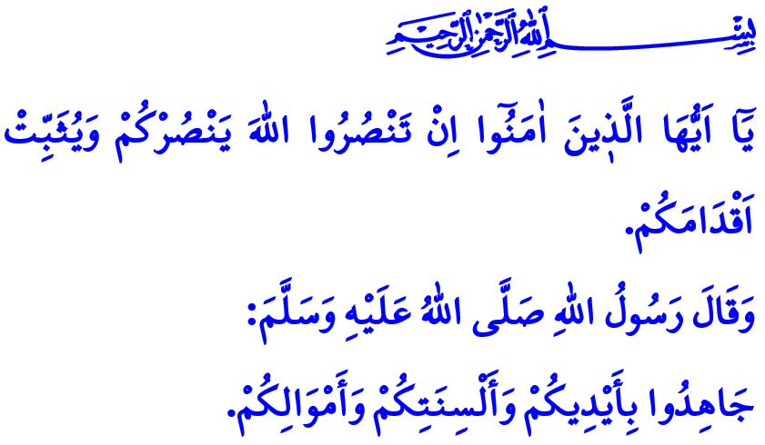
THE HELP OF ALLAH IS WITH OUR GREAT NATION
Honorable Muslims!
In the verse I recited at the beginning of the khutbah, our Almighty Lord (swt) states, “O believers! If you stand up for Allah, He will help you and make your steps firm.”
In the hadith I read, our Prophet (saw) says, “Strive with your hands, your tongues, and your wealth.”
Dear Believers!
We have been a nation wholeheartedly devoted to the sublime religion of Islam throughout history. Our hearts have been aflame with the love of I‘la Kalimat Allah, that is, the glorification of the name of Allah (swt). We have never deviated from the goal of making right and truth, peace and tranquillity, justice and goodness reign over the earth. Endless praise and thanks be to Allah the Almighty (swt), Who has always helped our great nation, the enemy of the oppressor, and the hope of the oppressed. When the believing hearts stood supplicating, مَتٰى نَصْرُ اللّٰهِۜ “When will Allah’s help come?”, our Lord (swt) became the helper of believers through His address, اَلَٓا اِنَّ نَصْرَ اللّٰهِ قَر۪يبٌ “Indeed, Allah’s help is always near.”
Dear Muslims!
The Victory of Malazgirt on August 26, which made Anatolia, the guarantee of our independence and survival, our homeland, is a testimony that Allah the Almighty (swt) has not deprived our great nation of His help and grace. The Victory of Çanakkale, where we defeated those who wanted to occupy our homeland with the most powerful navies, is a witness to this. The spirit of the National Struggle, in which we said “Stop!” to the disgraceful offenses despite all poverty and impossibilities, is another witness to this. The Victory of the Great Offensive on August 30, in which faithful hearts full of love for the homeland drove the enemies out of our Anatolia, is also a testimony to this.
Dear Muslims!
Those who want to divide our homeland and take our nation captive are as present today as they were yesterday. Our greatest ideal is to raise generations who will run for martyrdom without blinking an eye, full of love for the homeland, without ever forgetting this reality. The following lines, expressed by our poet of the Turkish national anthem a century ago, show that we, as a nation, should always carry this spirit with us:
Who would not sacrifice their life for this paradise of a country?
Martyrs would burst forth should one simply squeeze the soil! Martyrs!
May Allah take my life, my loved ones, and all possessions from me if He wills,
But let Him not deprive me of my one true homeland in the world.
Dear Believers!
What falls upon us today is to be alert against those who want to sow seeds of discord and mischief among us. Today, more than ever, it is our duty to work hand-in-hand, shoulder-to-shoulder, and heart-to-heart. Embracing the morality of brotherhood and strengthening our unity and solidarity is our duty today. We should keep alive the spirit of conquest that has made these lands a Muslim homeland for centuries. We should also protect the sacred values for which our glorious ancestors sacrificed themselves as martyrs and pass these values on to future generations.
I would like to take this opportunity to remember with mercy our great martyrs who sacrificed their lives to glorify the name of Allah (swt) and entrusted this heavenly homeland to us, and our heroic veterans who departed to the eternal world. May their resting place be in heaven, and their ranks be high. I would like to wish our living veterans good health, well-being, and a good life. May Allah the Almighty (swt) help our heroic army and security forces who are fighting day and night for the survival of our homeland and the peace and security of our nation. May Allah protect them from all evil and misfortune.

Muhammad, 47/7.
Nasa‘i, Jihad, 48.
Baqarah, 2/214. General Directorate of Religious Services

