Date: 23.04.2021
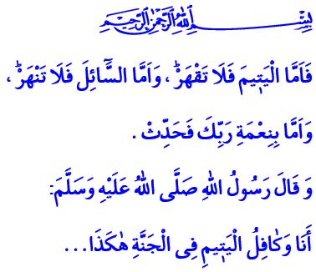
The Orphan: Allah the Almighty's Entrustment to Humanity
Honorable Muslims!
The Battle of Uhud was over, and Muslims were back in Madinah. A little kid came by the Prophet (saw) and asked him, “What happened to my father?” The words poured from the mouth of the Messenger of Allah (saw), “Your father was martyred; may Allah’s mercy be upon him.” Hearing these words, the kid started to cry. The Messenger of Mercy (saw) could not bear the situation, took the kid between his arms and hugged him, and tried to comfort him saying, “Do not you cry.” Then, he said, “Maybe I would become your father, and Aisha would become your mother, would not you like it?” The kid started to brighten. He happily replied, “Yes! I would like that very much.” The Messenger of Allah (saw) embraced the entrustment of the martyred man and made the kid forget his loneliness and being an orphan.
Dear Believers!
Our sublime religion Islam commands us to guard, protect and take care of the orphan. It recommends treating the orphan sensitively and approach them compassionately and mercifully. For the orphan are the Almighty Allah’s innocent servants He (swt) has entrusted to all of us. The Prophet (saw) refers to this reality as follows, “The best house among the Muslims is a house in which there is an orphan who is treated well.”
Dear Muslims!
Neglecting and ignoring the orphan, leaving them abandoned and uncared is a grave sin. Violating their rights and setting eyes on their properties is a sin whose burden is too heavy to bear. In this respect, our Lord Almighty (swt) warns us in the Holy Qur’an as follows, “So as for the orphan, do not oppress [him]. And as for the petitioner, do not repel [him]. But as for the favor of your Lord, report [it].”
Dear Believers!
On one occasion, the Prophet Muhammad (saw) indicated his index finger and middle finger joined together, and said, “I and the guardian of the orphan will be in Heaven like that.”
Our great nation, connected from heart to the Messenger of Allah (saw), has throughout the history opened its arms for the orphan, the abandoned, the victimized, the oppressed and persecuted. Today, we should also open our hearts to the orphan with the same consciousness. Let us strive to increase the light in their eyes and the joy on their faces. Let us contribute to their upbringing as well-educated individuals with good morals. Let us stand by them both materially and spiritually, and be the hope for their future. Let us remember that extending a helping hand for the orphan means to attain the pleasure of our Lord (swt).

Ibn Hajar, Isaba, I, 302.
Ibn Majah, Adab, 3.
Duha, 93/9-11.
Bukhari, Talaq, 25. General Directorate of Religious Services

