Date: 10.02.2023
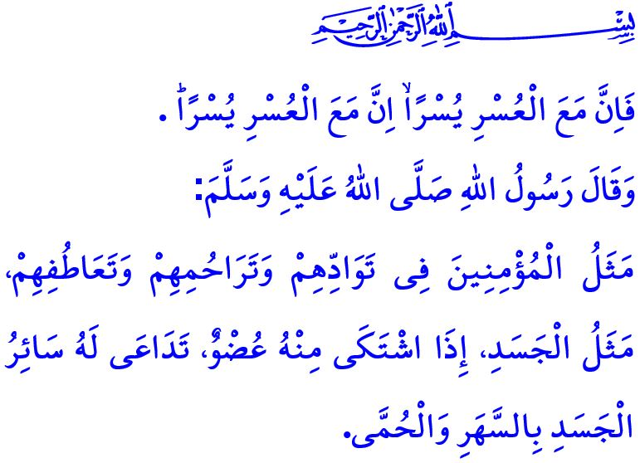
TODAY IS THE DAY TO UNITE
AS A NATION
Dear Muslims!
As a nation, we were shaken by huge earthquakes that burned our hearts. The fire burned not only where it fell but also all our hearts. We have been waiting by the rubble with prayers on our tongues and hope in our hearts. We are mobilized together to save our lives and to reach out to each other.
Dear Believers!
In this respect, the Prophet Muhammad (saw) describes believers as follows, “The similitude of believers in regard to mutual love, affection and fellow-feeling is that of one body; when any limb of it aches, the whole body aches because of sleeplessness and fever.”
So, my believer brothers and sisters! Today is the day to unite. Today is the day of solidarity and helping each other. Today is the day to seek refuge in Allah the Almighty (swt) through prayer and supplication, and to ask for His boundless mercy and help. So, today, as in the past, let us act with the consciousness of unity, solidarity, and brotherhood as a requirement of our faith. Let us be each other’s hope and joy of life. Let us touch the hearts of each of our earthquake-affected brothers and sisters, and wipe away their tears. Let us share their sorrow and soothe them. Let us be with our brothers and sisters with all our material and immaterial means. May our hearts be like a stove where they can feel warm on cold winter nights and a home where they can lay their heads. In times like these, let us maintain our common sense and calmness more diligently. Let us avoid all kinds of words and behaviors that may harm our unity and brotherhood.
Dear Muslims!
Our Lord Almighty (swt) states in the Holy Qur’an as follows: فَاِنَّ مَعَ الْعُسْرِ يُسْرًاۙ اِنَّ مَعَ الْعُسْرِ يُسْرًاۜ “So, surely with hardship comes ease. Surely with that hardship comes more ease.” Yes, we believe that this difficulty will be followed by ease, and this hardship will be followed by relief, with the hope and calm that our Lord has showered upon our hearts. We know that our great nation, which has overcome all kinds of difficulties shoulder to shoulder and heart to heart, will hopefully heal its wounds again with the prudence and wisdom it possesses, the mercy and grace of our Lord (swt), and the might and efforts of our state.
I would like to take this occasion to wish Allah the Almighty’s (swt) mercy on all our brothers and sisters who have lost their lives in disasters from the past to the present, extend my condolences to their relatives and our nation, and wish a speedy recovery to our wounded citizens. May our Lord Almighty (swt) never let us experience such pains again. May Allah the Almighty (swt) protect our country, our nation, and all of humanity from all kinds of disasters.
Dear Believers!
We are very pleased that many aid campaigns have started to help our brothers and sisters affected by the earthquake. As the Presidency of Religious Affairs, in order to support these campaigns, we will appeal for the help of our beloved nation in all our mosques outside the earthquake-affected provinces after Friday prayers today. These aids, full of love and affection of our nation, will be delivered to our brothers and sisters. May all these aids enable us to earn Allah the Almighty’s (swt) pleasure.

Muslim, Birr, 66.
Sharh, 94/5-6. General Directorate of Religious Services

