DATE: 11.12.2020
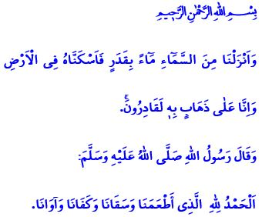
WaTER: SOURCE OF LIFE AND HEALING
Dear Muslims!
Water is one of the most precious blessings bestowed upon us by Allah (swt). As expressed in the Holy Qur’an, “every living thing was made from water” and lives a life dependent on water. Water is the source of our life and the abundance and fertility of our land. Through water comes health and cleanliness to our bodies, mercy and beauty to our environment.
Honorable Muslims!
Our exalted religion Islam commands us not to waste water but to use it in moderation. As a matter of fact, the Messenger of Allah (saw) warned a Companion who was using too much water while performing ablution saying, “What is this extravagance?” When the Companion asked “Can there be any extravagance in ablution?”, he (saw) replied as, “Yes, even if you are on the bank of a flowing river.” This warning of the Prophet (saw) reminds us that water is a rare blessing that should never be wasted even for the purpose of worship.
Dear Muslims!
Allah the Almighty states in the Holy Qur’an: “And We have sent down rain from the sky in a measured amount and settled it in the earth. And indeed, We are Able to take it away.”
We all know that the treasure of water is priceless. If our water is taken away to the depths of the earth, no one can bring it back to us but our Lord (swt).
While there are millions of people on earth devoid of a drop of clear and fresh water, what falls upon us is endless gratitude only. “Praise is due to Allah Who fed us, provided us drink, sufficed us and provided us with shelter!”
As a requirement of our gratitude, let us appreciate the value of the blessing and act consciously while using water. Let us not jeopardize our future by consuming more water than we need. Let us not fall into sin by violating the rights of other living beings.
Dear Brothers and Sisters!
As you know, our country needs water and rain nowadays when we are going through the driest year of the recent times. I would like to invite you, our beloved congregation, to the rain prayer we will be doing after performing the fardh of Friday prayer.

Anbiya, 21/30.
Ibn Majah, Taharah, 48.
Mu’minun, 23/18.
Muslim, Dhikr, 64. General Directorate of Religious Services

